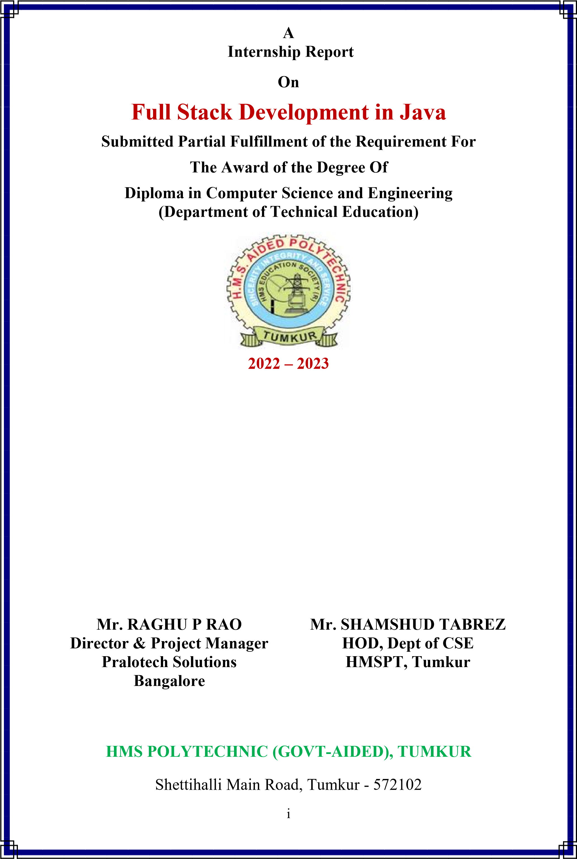 **Submitted By: Under the Guidance of:**

**DIVYAPRADA G Mrs. NOOR AISHA**

**306CS21016 Selection Grade Lecturer**

**CS, 6th Sem**   **HMSPT, Tumkur**

**Internship Incharge: Submitted To:**



**PraLoTech Solutions LLP**

P

raL

oTech

Solutions Certifies

**JOCELYN ADRIAN PARSONS**

**[**

**306**

**CS**

**20018**

**]**

For

successfully completing

Training and Internship Programme Conducted

between

**1**

**st**

**March**

**202**

**3**

to

**3**

**rd**

**J**

**une**

**202**

**3**

We take the pleasure in recognizing the achievement

With

the award of

**“**

**Internship Certificate**

**”**

I

n

**“**

**JAVA FULL STACK DEVELOPEMENT**

**”**

Given

on the

**3**

**rd**

day

of

**June**

**202**

**3**

Project Manager

& Director

PraLoTech Solutions LLP

#1, Silicon Plaza, Near T. C. Palya Signal, Subhashnagar, K. R. Pura, Bangalore

-

560 049



**REG NO:**

**AAN8688**

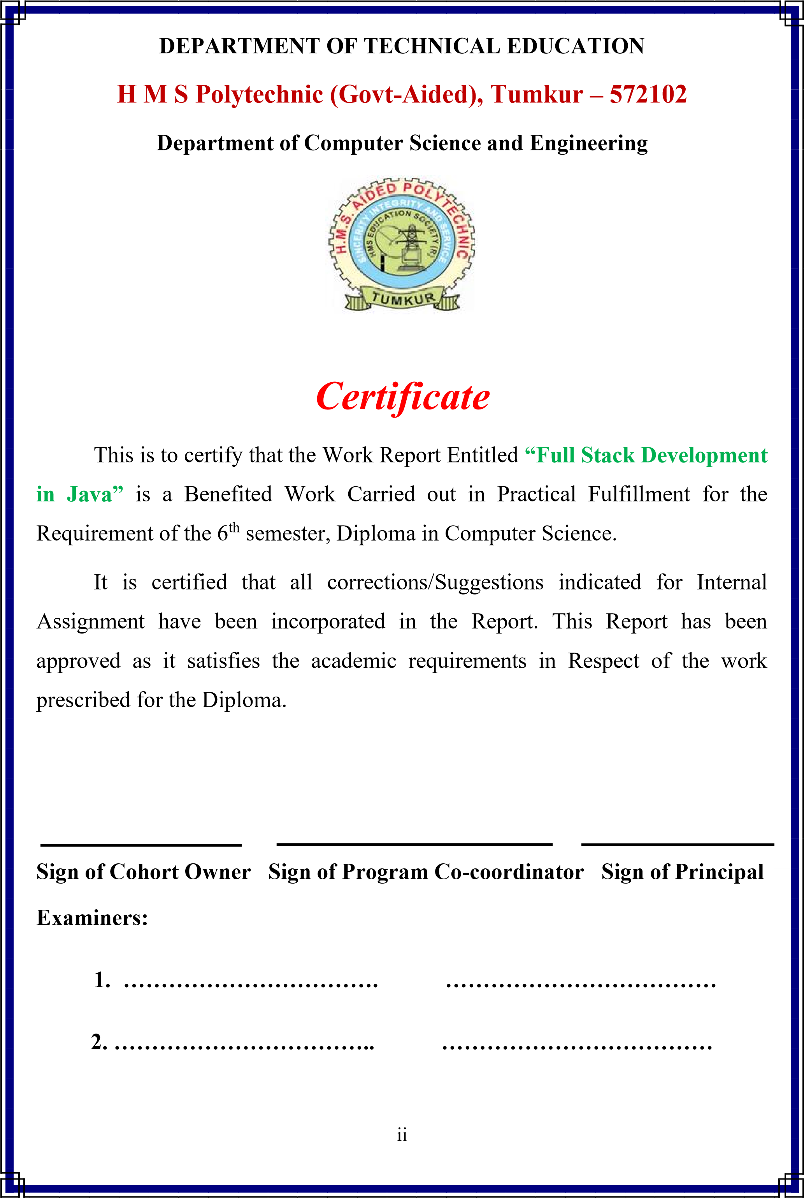

# ACKNOWLEDGMENT

The Satisfaction and Euphoria that Accompany The Successful Completion of Any

Task Would Be Incomplete Without The Mention of The People Who Made It Possible, Whose Insistent Guidance and Encouragement Crowned Out Efforts With Success.

I consider It’s my Privilege To Express My Gratitude and Respect To All Those Who Guided me In the Completion OF this Internship.

I Express My Sincere Gratitude To **MR. RAHAMATHULLA KHAN, (Principal of** **HMSPT,** Tumkur For Providing A Congenial Environment and Surrounding TO Work In.

I Express My Sincere Gratitude TO My Internship Guide, **MR. SHAMSHUD**

**TABREZ, (Head Of the Department)** Computer Science And Engineering, HMSPT, Tumkur For His Able Guidance And Support Throughout The Tenure of the Internship.

I Express My Sincere Gratitude To My Cohort Owners **Mrs. Noor Aisha** **(S G Lecturer), and Mr. Samiulla B A (S G Lecturer)**In the Computer and Engineering Department For Their Guidance and Support Throughout the Semester.

I Express My Sincere Gratitude To My Lecturers **Mr. Siddaramaiah (S G Lecturer), and Mr. Prahalada T** **(Lecturer)** In the Computer and Engineering Department For Their Guidance and Support Throughout the Semester.

I Express My Sincere Gratitude To My Internship Supervisors **Mr. Raghu p Rao**

**(Project Developer & Director), and Mr. Lohith C** **(Director & Project Manager)** In the Computer and Engineering Department For Their Guidance and Support Throughout the Semester.

Last But Not Least, I Wish to Thank All My Friends Who Extended Their Help And Co-Operation to me.

**By – DIVYAPRADA G**

**306CS21016**

## Executive Summary

This executive summary provides a concise overview of full-stack development, highlighting its importance and benefits in the realm of web development.

Full stack development refers to the practice of creating and maintaining all components of a web application, including the user interface, server-side logic, and database interactions. Full-stack developers possess a comprehensive understanding of both frontend and backend technologies, allowing them to bridge the gap between the two and build end-to-end solutions.

By embracing full-stack development, organizations and developers can experience several advantages. Firstly, full stack developers possess a holistic view of the entire application, enabling them to efficiently collaborate with different teams and contribute to multiple stages of the development process. This integrated approach streamlines communication and enhances productivity.

Additionally, full-stack development provides flexibility and agility. Developers can switch between different tasks and technologies, adapting to changing project requirements and optimizing development cycles. This versatility reduces reliance on external resources and promotes a faster time-to-market for web applications.

Full-stack development also empowers developers to create seamless user experiences. With a deep understanding of frontend technologies, they can design and implement intuitive and visually appealing user interfaces. Simultaneously, their backend expertise ensures robust server-side logic and efficient database interactions, resulting in a smooth and responsive application.

To excel in full-stack development, developers need a diverse skill set. Proficiency in frontend technologies such as HTML, CSS, and JavaScript is essential, along with expertise in frontend frameworks like React or Angular. On the backend side, knowledge of server-side languages such as Node.js, Python, or Ruby is crucial, along with familiarity with databases and web servers.

### CONTENTS

Numbers of Figures **3 Page no**

Number of Tables **1**

1. **ABOUT THE COMPANY 1**

* 1. Brief History of the Organization 1

* 1. Overall Organization Structure 2

* + 1. Vision 2
    2. Our Values 2
    3. Our Goals 3
    4. Mission 4
  1. The Product and the Service Offered By Organization. 5

1.3.1 Corporate Philosophy 5

* 1. Number of people Working in the organization 6

* 1. Financial Details 6

* + 1. Growth Record 7
    2. Partnership 7
    3. Experience Certainty 8
    4. Overall Turnover or Operational Cost of Organization 8

* 1. Organization Structure of the Company. 9
     1. Current Research and Development 10
     2. New Technology Capability and Positions 10
     3. Responsibilities of the Internship 11

1. **Team Works** 
   1. Ready to Learn New Things 13
   2. Communications Skills 13
   3. Tasks Assigned for the Interns 13
   4. Quantity of work 13
   5. Work Ethics 14
   6. Job Knowledge and Competency 14
   7. Teachability 14
   8. Communication 14
   9. Interns Job Role and Responsibilities 14
   10. Challenges Faced in Internship 14

**3. Introduction 15**

* 1. Objective of Study 16
  2. Scope of Study 17
  3. Limitations of Study 18
  4. Architecture 19
  5. Data Flow Diagram 20
  6. Objectives of the work 20
  7. Technologies Learnt 20
  8. Internship Road Map 21

**4. Use Case - 1 22**

* 1. User Stories for Search Movie 22
  2. User Stories for View Movie Details 22
  3. User Stories for Add Movie and Show Timings 23
  4. User Stories for Edit Movie 24
  5. User Stories for Booking Movie 24

**Use Case – 2 35**

* 1. User Stories for Customer Registration 26

4.6.2 User Stories for Customer Login 26

4.6.3 User Stories for Search Movie 27

4.6.4 User Stories for View Movie Details 27

4.6.5 User Stories for Theatre Owner Registration 28

4.6.6 User Stories for Theatre Owner Login 28

4.6.7 User Stories for Add Movie and Show Timings 29

4.6.8 User Stories for Edit Movie 30

4.6.9 User Stories for Booking Movie 30

4.6.10 User Stories for Cancel Booking 31

4.6.11 User Stories for Logout 31

**LIST OF FIGURE**

Figure No Figure Name **Page No**

1.6 Organization Structure of the Company 09

2.0 Teamwork 12

* 1. Architecture 19
  2. Data Flow Diagram 20

3.8 Internship Road Map 21

**Use Case – 1 22**

**Use Case - 2 26**

**CHAPTER 1**

#### ABOUT THE COMPANY

**1.1 Brief history of the Organization**

With the active participation of its multi-disciplinary Assignment Execution Team, Pralotech Solutions has emerged as a leader in the ITES in India and has established itself in the field of software development, data processing, data conversion, digital printing, Digitization, System integration, smart card personalization, IT facility management and other IT enabled services. Pralotech Solutions LLP, incorporated in end of 2018, is a professionally managed, rapidly growing, multifaceted Information technology company. The company is actively involved in developing automation and e-Governance solutions for Transport, Social Security, Citizen Identity, Education, Public Distribution System, Retail Management and a host of other application areas.

Pralotech Solutions is a leading System integrator in India providing complete turnkey solutions on BOO & BOOT basis including facility management services, Smart Cards applications, Document Management System (DMS), Work Flow Management and Manpower Deployment.

Pralotech Solutions has successfully completed many e-governance projects for the various departments of Govt of Karnataka and has won accolades for its superior service delivery, timely execution of projects and the quality of the deliverables. PRALOTECH SOLUTIONS is being trusted by many clients who are looking for reliable and quality services for their business. PRALOTECH SOLUTIONS is currently operating and managing in Bangalore and giving services to e-commerce business services.

Pralotech Solutions adopted project team and dedicated organization structure. In project based organization, the project managers directors have a high level of power to oversee and control the project assets. The project manager in this structure has downright power over the project and can secure assets expected to fulfill project targets from inside then again outside the parent organization, subject just to the extension, quality, furthermore, budget constraints are identified in the project.

In the project based structure, staff is particularly relegated to the project and report specifically to the project manager. The project manager is in charge of the execution evaluation and vocation movement of all undertaking colleagues while on the project. This prompts expanded project faithfulness. Complete line power over undertaking endeavors bears the project manager solid undertaking controls and brought together lines of correspondence. This prompts quick response time and enhanced responsiveness. In addition, project work forces are held on a restrictive instead of shared or low maintenance premise. Project teams create an in number feeling of task recognizable proof and possession, with profound faithfulness efforts to the project and a decent comprehension of the way of project's exercises, mission, or objectives.

**1.2 Overall Organization Structure**

Pralotech Solutions is completely dedicated to the success of our customers and does not permit external forces to diminish our focus and commitment. To achieve the highest level of customer satisfaction, we follow basic principles to deliver solutions with impact.

**1.2.1 Vision:**

Vision Statement: “To be the pioneer in e-commerce solutions by building and implementing robust and future proof systems which are efficient, transparent and accountable.”

**1.2.2 Our Values:**

The core values which lay the foundation for Pralotech Solutions are:

* Honesty & Integrity: Pralotech Solutions individual and business relationships are governed by the highest standards of honesty and integrity. People at all levels adhere to the code of conduct and the highest standards of business ethics, as they believe in conducting their business with uncompromising integrity.
* Respect & Dignity: Pralotech Solutions respects its customers, recognize that they have different needs and continuously strive towards satisfying those needs by improving the quality of its solutions and services. It trust and respect its people and recognize their contributions to Pralotech Solutions.
* Terms Spirit & Camaraderie: Pralotech Solutions believes that focus on Team Work is its competitive advantage. Teams act as catalysts for successful achievement of the organizational goals. Individuals are encouraged to interact with all levels of management, freely share their ideas and suggestions and work together as a cohesive unit.
* Openness & Transparency: Pralotech Solutions has an open and transparent culture. Openness facilitates informed decisions, shared understanding and builds an environment of trust in the organization.
* Empowerment: Pralotech Solutions employs high caliber people who take responsibility for their actions and exercise good judgment in an environment of mutual trust. Pralotech Solutions seeks to retain its entrepreneurial spirit and minimize bureaucracy.
* Core Values: When we take on your project, we take the stewardship of the project with you in the director’s seat. As stewards of your project, we consider ourselves successful not when we deliver your final product but when the product meets your business objectives.
* Integrity: Honesty in how we deal with our clients, each other and with the world.
* Candor: Be open and upfront in all our conversations. Keep clients updated on the real situation. Deal with situations early; avoid last minute surprises.
* Service: Seek to empower and enable our clients. Consider ourselves successful not when we deliver our client’s final product but when the product is launched and meets success.
* Kindness: Go the extra mile. Speak the truth with grace. Deliver more than is expected or promised.
* Competence: Benchmark with the best in the business. Try new and better things Never rest on laurels. Move out of comfort zones. Keep suggesting new things. Seek to know more.
* Growth: Success is a journey, not a destination. Seek to multiply/increase what we have - wealth, skills, influence, and our client’s business.

**1.2.3 Our Goal:**

**Our company objectives as follows:**

* To promote a profitable and sustainable business activity that meets the customer’s needs.
* To increase the company's market share
* To gain the competitive edge
* To increase the company's role in relations to social responsibility
* To provide excellent customer service

**1.2.4 Mission:**

“To enable its customers to achieve total e-commerce through innovative solutions using the cutting edge technologies and to provide world class IT and ITES services at affordable costs to the customers with fast turnaround time and to continually improve the service delivery at the client service centre’s managed by us.”

Over the next few years our goal is to harness our talents and skills by permeating our company further with process-centered management. In this way, once a customer's project enters our quality oriented process, it will exit as a quality product.

We will also strive to add to our knowledge and enhance our skills by creating a learning environment that includes providing internal technology seminars, attending conferences and seminars, building a knowledge library and encouraging learning in every way. Our in-house Intranet portal makes sure that knowledge is shared within the organization.

With our beliefs, the future can only look promising as we continue to build our team with the best Indian talent and mould them into our quality-oriented culture. We will find our niche in a competitive world by excelling at what we do, following our guiding principles and most importantly, listening to the needs of our customers, to complete within deadline period is also our mission.

**Contact Information**

**Company Name :** Pralotech Solutions LLP

**Development &**

**Data Processing Centre:** #1 Silicon Plaza, Near Usha Dental Clinic,

Subhash Nagar, T C Palya, K R Puram,

Bangalore-560049

**General Phone No :** 9611431872, 9164884137

**Company Email :** info@pralotech.com, pralotechsolutions@gmail.com

**Website :**  www.pralotech.com

**Contact Person :** Mr. Lohith C(lohith@pralotech.com)

**1.3 The Products and the Services Offered By**

**Organization**

Company offer the key products and services you would expect from a leading Microsoft Gold and Oracle partner including Web, Software Development and Mobile application, Integration, Consultancy and Support Services.

What sets us aside is our focus, vision and capability to deliver. We are highly accredited, come highly recommended and invest heavily in both product development and our first class consultants.

Pralotech Solutions LLP is one of India most well-known and well-trusted solution provider. Today, Pralotech Solutions stands as a source of reliable and innovative products that enhance the quality of costumer's professional and personal lives.

Its employees in all the branches are active in the areas of production, software development, Implementation, system integration, and training.

**Why PraloTech?**

With a client list spanning nearly in all industries, and colleges, Pralotech Solutions product solutions have benefited customers of many different sizes, from non-profit organizations to companies.

By acquaintance with Pralotech Solutions, you’ll have access to current IT research, tools, templates, and step-by-step action plans for completing Key projects. You’ll also be provided full access to our research archives and knowledge base.

**1.3.1 Corporate Philosophy**

* **Quality Policy:** “Pralotech Solutions is committed to provide world class Information Technology Enabled Services (ITES) to its customers with high accuracy, unmatched quality and fast turnaround time”.
* **Security Policy:** “Pralotech Solutions understands that the trust of the client in it depends on how well it keeps their personal, business and accounts information secure. PRALOTECH SOLUTIONS follows international standards set under Information Security Management System (ISMS) policy guidelines.”

**1.4 Number of People Working In the Organization**

Pralotech Solutions employs more than 50 professionals with various skill set and professional competence. Have different project execution teams for different application areas in Information Technology Industry. The Human Resources available with Pralotech Solutions, their qualification and technical skills are depicted below.

Human capital is our most important asset. A qualified and highly specialized team with multi-disciplinary approach forms the technical core at Six Axis. This repository of talented and committed software developers has a proven track record to ensure success in IT solution implementation. With skills ranging from business process re-engineering to application development, Pralotech Solutions technical team seeks to constantly enhance and expand its technical knowledge. Capturing knowledge through procedures and processes is the premise on which the entire organization works. Pralotech Solutions resource base consists of IIT engineers (three including the Directors), management graduates, masters in computer applications and domain experts from various fields.

Pralotech Solutions have improved the quality of communication and satisfied customers. We have earned their respect by providing excellent products and services. In addition, we are flexible with services and financial structures for contracts aiming for mutually beneficial relationships with our customers.

Our customers are dynamic and diverse and include Large Corporate

Offices, Universities, Educational Institutions, Factories, etc

**1.5 Financial Details**

PRALOTECH SOLUTIONS provides flexible investment solutions, such as leasing, financing, utility programs and asset management services, for customers to enable the creation of unique technology deployment models and acquisition of complete IT solutions, including hardware, software and services from PRALOTECH SOLUTIONS and others.

Providing flexible services and capabilities that support the entire IT lifecycle, partners with customers globally to help build investment strategies that enhance their business agility and support their business transformation. PRALOTECH SOLUTIONS offers a wide selection of investment solution capabilities for large enterprise customers and channel partners, along with an array of financial options to SMBs, educational and governmental entities.

Corporate Investments Corporate Investments includes PRALOTECH SOLUTIONS Labs and certain cloud-related business incubation projects among others. Sales, Marketing and Distribution We manage our business and report our financial results based on the business segments described above.

**1.5.1 Growth Record**

Since its inceptions and with initial small steps, Pralotech Solutions is now progressing by leaps and bounds. It has grown from a small venture to a medium scale enterprise with a strong 80+ workforce, our rate of more than 100%. The company is executing some of the prestigious projects and has earned a very respectable name in the Indian IT and e-commerce industry.

**1.5.2 Partnership**

Our innovative and highly integrated approach means customers benefit from working with specialists. Our continuous strive to be a technology leader in the industry means that our clients directly benefit from the huge expertise that our people possess.

We strive to be at the forefront of technology that enables us to provide you with highly effective and optimized solutions to all your problems. Clients like to have a single point-of-contact for their solutions, and expect a complete solution from the vendor, which is not possible unless there are partnerships and alliances within and outside the company.

Pralotech Solutions fosters partnerships with companies with whom a value proposition can be offered to clients.

One of the key benefits that you receive by partnering with Pralotech Solutions is increased project completion certainty, project transparency, renewed customer confidence and credibility from our unparalleled track record, mature processes and quality recognition and customer endorsement.

**1.5.3 Experience Certainty**

True certainty of success comes from working with a partner you trust to provide the insight, support and expertise that will propel your business forward. Experiencing certainty with Pralotech Solutions means you can count on results, partnership and leadership. When you work with us, your long-term success is our motivation. This is why we can offer you the ability to meet every challenge and the ability to capitalize on every opportunity. That’s the power of certainty. And it is our promise to every client.

**1.5.4 Overall Turnover or Operational Cost of Organization**

For most of our products, we have existing alternate sources of supply or such alternate sources of supply are readily available. However, we do rely on sole sources for laser printer engines, LaserJet supplies, certain customized parts and parts for products with short life cycles (although some of these sources have operations in multiple locations in the event of a disruption). We are dependent upon Intel and AMD as suppliers of x86 processors and Microsoft for various software products; however, we believe that disruptions with these suppliers would result in industry-wide dislocations and therefore would not disproportionately disadvantage us relative to our competitors.

See ‘‘Risk Factors—we depend on third-party suppliers, and our financial results could suffer if we fail to manage suppliers properly,’’ in Item 1A, which is incorporated herein by reference. Like other participants in the IT industry, we ordinarily acquire materials and components through a combination of blanket and scheduled purchase orders to support our demand requirements for periods averaging 90 to 120 days. From time to time, we may experience significant price volatility or supply constraints for certain components that are not available from multiple sources.

Frequently, we are able to obtain scarce components for somewhat higher prices on the open market, which may have an impact on our gross margin but does not generally disrupt production. We also may acquire component inventory in anticipation of supply constraints or enter into longer-term pricing commitments with vendors to improve the priority, price and availability of supply. See ‘‘Risk Factors— we depend on third-party suppliers, and our financial results could suffer if we fail to manage suppliers properly,’’ in Item 1A, which is incorporated herein by reference. Research and Development Innovation is a key element of our culture. Our development efforts are focused on designing and developing products, services and solutions that anticipate customers’ changing needs and desires, and emerging technological trends.

Our efforts also are focused on identifying the areas where we believe we can make a unique contribution and the areas where partnering with other leading technology companies will leverage our cost structure and maximize our customers’ experiences. PRALOTECH SOLUTIONS together with the various research and development groups within our business segments, are responsible for our research and development efforts. We anticipate that we will continue to have significant research and development expenditures in the future to support the design and development of innovative, high-quality products and services to maintain and enhance our competitive position. For a discussion of risks attendant to our research and development activities, see ‘‘Risk Factors— If we cannot successfully execute on our strategy and continue to develop, manufacture and market products, services and solutions that meet customer requirements for innovation and quality, our revenue and gross margin may suffer,’’ in Item 1A, which is incorporated herein by reference.

**1.6 Organization Structure of the Company**

**ADVISORY AND**

**GOVERNING BOARD**

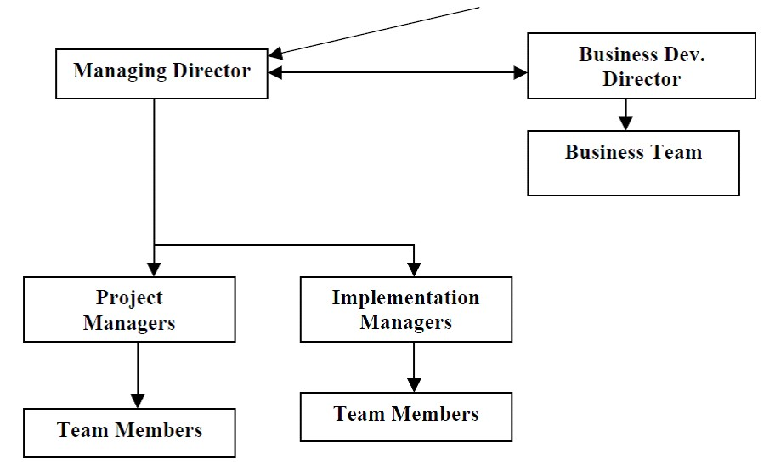

**Fig. 1.1 Organization Structure**

**1.6.1 Current Research and Development**

* The current R & D efforts are primarily aimed at the following segments in the healthcare industry:
* Developing a system for integrating medical schools with major hospitals for knowledge gathering, sharing and learning
* Developing a Clinical Decision Support System to aid doctors in difficult to diagnose cases using Artificial Intelligence and Probabilistic Techniques.

**1.6.2 New Technology Capability and Positions**

The organization has a process in place, which addresses the issue of incorporating emerging technologies into the product design. The process is as follows:

* Core committee on new development evaluates and identifies new technology for the purpose of integration.
* The research and development department identifies the resource and people and 1formulates the process for working while setting key performance indicator.
* A thorough study of the new technology along the tools is made and documented.
* Estimates are made as to the impact of the new technology on the products developed by the company.
* Effort estimates are made for introducing the new technologies
* Client feedback is received about the efforts needed and the advantages of the new technology.
* The core committee takes a knowledgeable decision as to the advantages and efforts required and approve the introduction of the technology
* The affected personnel are trained in the new technologies
* The new technology is introduced and the product is enhanced
* The clients are informed about the enhancement and introduction of related documents are prepared for the changeover
* The clients are guided in implementing the new technologies

Being a technology driven company we are always exploring ways of enhancing our product capabilities and aim at providing the latest state-of-the-art products to our customers. We have incorporated the PDAs and the smart card already in the system. We are currently evaluating blue tooth capability and the Tablet PC relevance to the field.

**1.7 Responsibilities of the Internship Student During the internship, the student is responsible for the following:**

1. Discuss progress and engage in discussion of topics relevant to the operation and philosophical perspective of the office and functional area in general.
2. Carry out established activities and any additional responsibilities which are mutually agreed upon by the student and site supervisor.
3. Fulfill agreed upon time commitments.
4. Conduct oneself in a responsible and professional manner.
5. Raise concerns with the site supervisor and seminar instructor if the objectives for the internship are not being met or if the supervision being received is inadequate.

#### CHAPTER 2 2. TEAMWORK



**Teamwork**

You must be a team player. Teamwork establishes a method for meeting deadlines and producing high-quality work. When one teammate falls behind, another step in to pick up the slack.

When work is distributed among team members, it is completed faster, allowing the business to operate more efficiently. As you work toward a common objective, your team will build a sense of togetherness.

**2.1 Ready to learn new things**

Knowledge is limitless. Successful Java developers are always on the lookout for new technological advancements and keep themselves up to date.

**2.2 Communication Skills**

Good communication skills aid in the development of greater understanding and beliefs among individuals, inspiring them to adhere to the concepts and ideals instilled in them by their leader.

Active listening, in which you pay great attention to the person speaking to you, and attempt to adjust your communication style to your audience in order to express your message more effectively, are example of good communication skills.

The better the communication Skills, the better chances of growth in one’s career.

**2.3 Tasks Assigned for the Interns**

Creation of Java Front End Applications and connecting to the database

Here each Intern has to take care of creation of User-Friendly GUI. Then Write a java backend code with Database connection using JDBC.

**Intern’s performance on assigned tasks and project to be finished and meet the following requirements.**

**2.4 Quantity of Work**

Meets productivity standards; completes work in a quick and timely manner; strives to increase productivity.

**Quality of Work**

Demonstrates accuracy and thoroughness; displays commitment to excellence; looks for ways to improve and promote quality; shows good attention to detail.

**2.5 Work Ethic**

Demonstrates a good work ethic; offers assistance and support to coworkers; willing to go the extra mile; makes maximum use of time.

**2.6 Job Knowledge and Competency**

Competent in required job skills and knowledge; exhibits ability to lean and apply new skills; keeps abreast of current developments in field; requires minimal supervision.

**2.7 Teachability**

Shows an openness and eagerness to learn from others; accepts criticism and feedback; applies feedback to improve performance; open to new ways of doing things.

**2.8 Communication**

Exhibits good listening and comprehension; expresses ideas and thoughts effectively; keeps other adequately informed; resolves conflict effectively and timely.

**2.9 Interns Job Role and Responsibilities**

* We have a group of 35 Members, each will getting the task to finish it. And we should report to project manager during meeting held at company weekly.
* Our team made for Development of Application with the help of java programming Language.

**2.10 Challenges Faced in Internship**

We are new to the Techniques and we facing the challenges during learning stage of Full stack development and cloud itself because Full stack Development and AWS is a vast to learn and make work as a fresher /intern, its bit difficult and it’s a challenging task to us.

**CHAPTER 3**

#### 3. INTRODUCTION

**Administrator's Hub:**

As the guardian of the Cinemax realm, administrators wield the power to orchestrate the perfect cinematic symphony. With unparalleled authority, they oversee every aspect of the system, from managing customers to nurturing relationships with theatre owners. The administrative dashboard provides a comprehensive view, allowing for effortless navigation through customer databases and theatre owner directories. Equipped with the ability to delete customers and theatre owners when necessary, administrators ensure the seamless functioning of Cinemax.

**Theater Owner's Corner:**

For theater owners, Cinemax is not just a platform; it's a stage to showcase cinematic brilliance. Empowered with the ability to add movies and set show timings, theater owners transform their venues into cinematic sanctuaries. Through the intuitive interface, they curate a captivating lineup of films, tailored to tantalize the senses of every moviegoer. With Cinemax, theater owners reignite the magic of cinema, one screening at a time.

**Customer's Oasis:**

Step into the world of Cinemax, where movie magic awaits at your fingertips. As a customer, your journey begins with a simple search, as you explore an extensive collection of movies and show timings. From the comfort of your own device, you can effortlessly browse, select, and book your preferred screenings with ease. With secure transactions and instant confirmations, Cinemax ensures that every movie experience is nothing short of extraordinary.

At Cinemax, we don't just offer a Movie Booking System; we present an immersive cinematic journey. Whether you're an administrator, a theater owner, or a valued customer, Cinemax invites you to embark on an unforgettable adventure, where the magic of movies comes to life. Welcome to Cinemax – where every moment is a masterpiece.

**3.1 Objective of study**

The objective of developing the Movie Booking System is to create a seamless and efficient platform that caters to the diverse needs of administrators, theater owners, and customers within the realm of movie entertainment. This system aims to achieve several

**Key objectives:**

1. **Streamlined Operations:** Simplify the process of movie booking and management for all stakeholders involved, minimizing manual efforts and maximizing efficiency.
2. **Enhanced User Experience:** Provide an intuitive and user-friendly interface for customers, theater owners, and administrators, ensuring a smooth and enjoyable experience throughout the booking process.
3. **Centralized Management:** Offer administrators a centralized platform to oversee and manage customer databases, theater owner directories, movie listings, and show timings, facilitating streamlined operations and decision-making.
4. **Empowered Theater Owners:** Equip theater owners with the tools and resources necessary to showcase a diverse range of movies and set flexible show timings, empowering them to attract audiences and optimize their venue's utilization.
5. **Convenient Customer Access:** Enable customers to effortlessly search, browse, and book movies and show timings according to their preferences, providing a convenient and hassle-free booking experience.
6. **Optimized Resource Allocation:** Enable administrators and theater owners to make informed decisions regarding movie selection, scheduling, and resource allocation, optimizing the utilization of available resources and maximizing profitability.

Overall, the objective of the Movie Booking System is to revolutionize the movie-going experience by leveraging technology to streamline operations, enhance user experience, and empower stakeholders across the board. By achieving these objectives, the system aims to become the go-to destination for movie enthusiasts and industry professionals alike.

**3.2 SCOPE OF STUDY**

The scope of study for the Movie Booking System encompasses a comprehensive exploration of various aspects related to the development, implementation, and utilization of the system. Key components within the scope include:

1. **Functional Requirements:** Analyzing and documenting the functional requirements of the Movie Booking System, including features such as user authentication, movie listing, show timing management, booking, payment processing, and administrative functionalities like customer and theater owner management.

2. **User Roles and Permissions:** Defining the roles and permissions of different user types within the system, such as administrators, theater owners, and customers, and specifying the actions and operations permitted to each role.

3. **Technical Infrastructure:** Assessing the technical infrastructure required to support the Movie Booking System, including hardware, software, networking, and database components, and determining the optimal configuration for seamless performance and scalability.

4. **System Architecture:** Designing the system architecture, including the overall structure, component interactions, data flow, and integration points, to ensure robustness, flexibility, and ease of maintenance.

5. **User Interface Design:** Developing intuitive and user-friendly interfaces for administrators, theater owners, and customers, with a focus on usability, accessibility, and responsiveness across different devices and platforms.

6. **Database Design:** Designing the database schema to efficiently store and manage data related to movies, theaters, show timings, bookings, users, and other relevant entities, while ensuring data integrity, security, and scalability.

7. **Security Measures:** Implementing robust security measures to protect sensitive data, prevent unauthorized access, and mitigate potential security threats, including authentication mechanisms, data encryption, and role-based access control.

8. **Integration with External Systems:** Evaluating the need for integration with external systems, such as payment gateways, movie databases, and third-party APIs, and implementing seamless data exchange mechanisms to enhance system functionality and interoperability.

9. **Testing and Quality Assurance:** Conducting comprehensive testing procedures, including unit testing, integration testing, system testing, and user acceptance testing, to ensure the reliability, performance, and correctness of the Movie Booking System.

10. **Documentation and Training:** Providing thorough documentation for system requirements, design specifications, installation procedures, user manuals, and maintenance guidelines, as well as conducting training sessions for administrators, theater owners, and support staff to ensure effective system utilization.

By delineating the scope of study across these dimensions, the development team can effectively plan, execute, and deliver a robust and user-friendly Movie Booking System that meets the needs and expectations of all stakeholders involved..

**3.3 LIMITATION’S OF THE STUDY**

While designing and implementing the Movie Booking System, it's important to acknowledge certain limitations that may impact the scope, accuracy, and applicability of the study. Some potential limitations include:

1. **Scope Constraints:** The study may have limitations in terms of its scope, focusing primarily on the technical aspects of the Movie Booking System while potentially overlooking broader considerations such as market analysis, legal compliance, or socio-cultural factors influencing movie preferences.
2. **Resource Limitations:** Constraints related to time, budget, and human resources may restrict the depth and breadth of the study, leading to compromises in the thoroughness of research, analysis, and implementation efforts.
3. **Technological Challenges:** The study may face challenges associated with the complexity and rapid evolution of technology, such as compatibility issues with legacy systems, dependency on external APIs or services, and constraints imposed by the chosen development frameworks or platforms.
4. **Data Availability:** Limited availability or quality of data sources may restrict the accuracy and reliability of the study's findings and conclusions, particularly in areas such as market research, user behavior analysis, or performance testing.
5. **User Acceptance:** The success of the Movie Booking System depends heavily on user acceptance and adoption, which may be influenced by factors such as user interface design, ease of use, and cultural preferences, posing challenges in predicting and addressing user expectations.
6. **Security and Privacy Concerns:** Ensuring the security and privacy of user data within the Movie Booking System presents inherent challenges, including vulnerability to cyber threats, compliance with data protection regulations, and maintaining user trust in handling sensitive information.
7. **External Dependencies:** The study may be subject to dependencies on external factors beyond its control, such as changes in industry regulations, market dynamics, or technological advancements, which could impact the feasibility and sustainability of the Movie Booking System.
8. **Geographical Limitations:** The study's findings and recommendations may be limited in their applicability to specific geographical regions or cultural contexts, necessitating customization and adaptation to suit diverse audience preferences and market conditions.
9. **Feedback and Iteration:** Despite rigorous testing and validation, the Movie Booking System may require iterative improvements based on user feedback, market trends, and evolving business needs, posing challenges in achieving initial perfection and long-term viability.
10. **Vendor Lock-in:** Dependence on third-party vendors for essential components or services of the Movie Booking System may introduce risks related to vendor reliability, service disruptions, and constraints on customization or scalability.

By acknowledging and addressing these limitations proactively, the study can mitigate potential risks and uncertainties, thereby enhancing the robustness and effectiveness of the Movie Booking System in meeting the needs of stakeholders and delivering value to end users.

* 1. **Architecture**

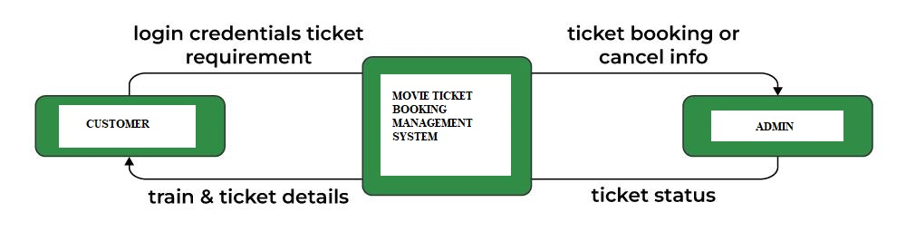

* 1. **Data Flow Diagram**

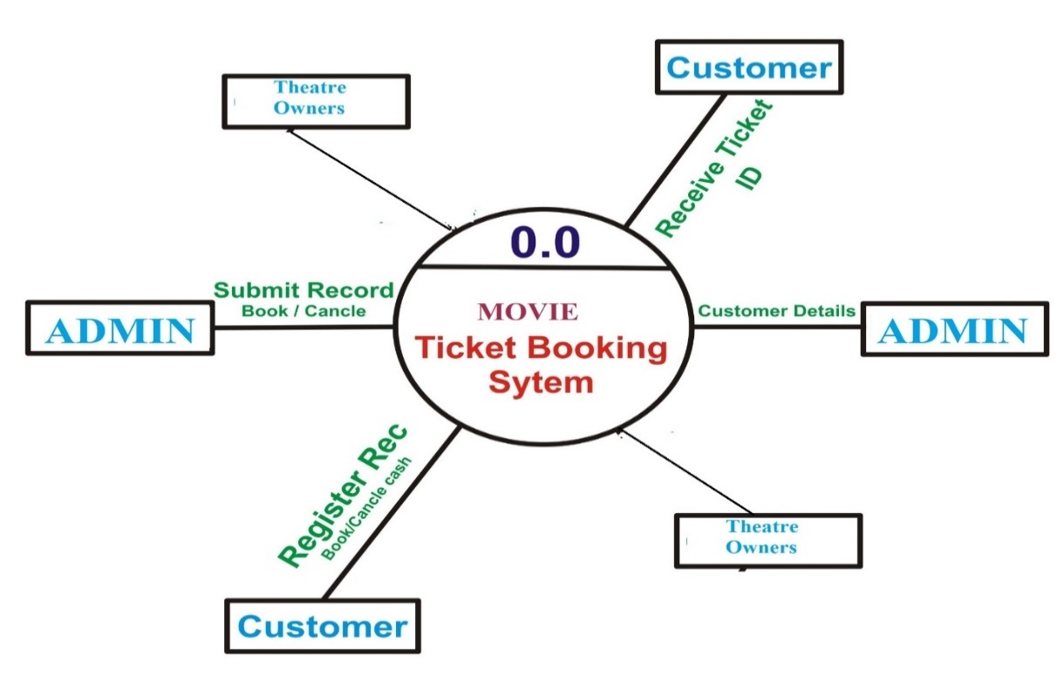

* 1. **Objectives of the work**
* The main objective of this internship was to gain hands on experience in real life situations and observe how an industry works.
* Assigned as an intern, I was mainly told to observe the process of developing a project . I worked along with the Engineers, throughout the process that provided me with various knowledge and experience on how to convert a concept or an idea into reality.

**3.7 Technologies Learnt**

* Java
* GUI Development
* Storage with Database, File Storage and Cloud Storage
* AWS Services

**3.8 Internship Road Map**

Development

Review

3

Problem

Identification

and finding

the solution

Review 2

Learning

Phase

Review 1

#### CHAPTER 4 USES CASE – 1

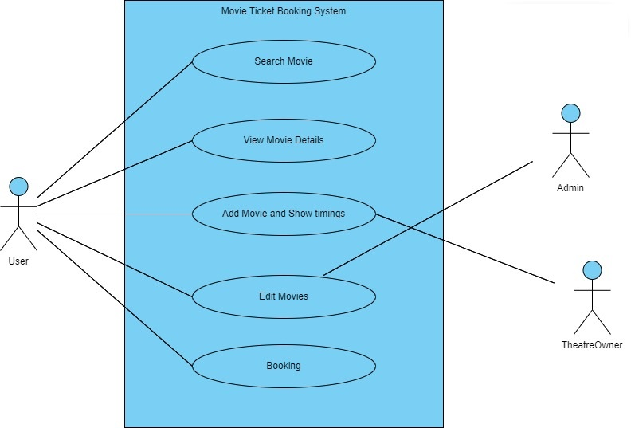

**4.1 User Stories for Search Movie**

**Search Movie:**

As a < user >

I want to < search for a movie in Movie Ticket Booking Application>

So that < I can book a Movie ticket in a specific theater.>

**Acceptance Criteria:**

1. While searching, valid theatre should be specified.

2. And also, Available movie in the theatre.

3. Checking for availability of a Movie ticket on specific date always should be current date and ahead of the current date.

4. Searching based on the theatre Location.

5. Price listing as per the theatre.

**4.2 User Stories for View Movie Details**

**View Movie Details:**

As a < user >

I want to < view the movie details in a Particular movie >

So that < I can easily book the movie ticket in the application >

**Acceptance Criteria:**

1. While view the movie details, its show the current theatre name, movie name and show timings.

2. And also, show remaining tickets available.

3. Checking about the movie description of the particular movie.

4. And also shows the movie ticket price.

5. Also view the new trending movie details.

6. View Trailers of currently running movies.

7. Shows the QR code or ticket number.

**4.3 User Stories for Add Movie and Show Timings**

**Add Movie:**

As a < admin >

I want to < add movies to the Movie Ticket Booking application >

So that < the customer’s can easily book the movie tickets >

**Acceptance Criteria:**

1. While adding the movie to the application, to add the movie name, theater name, add timings.

2. And also add the movie timings and price.

3. Adding the Sessions of the all movies.

4. Particular movie payment system are also added.

5. Add the theater location.

**Show Timings:**

As a < admin >

I want to < show timings of the particular movie and sessions >

So that < the customer can book movie tickets based on the their available timings >

**Acceptance Criteria:**

1. While view the movie details then show the particular movie timings.

2. Timings based on the morning, afternoon and night sessions.

3. Showing the Upcoming movies timings list.

**4.4 User Stories for Edit Movie.**

**Edit Movie:**

As a < admin >

I want to < Edit the movies >

So that < the customer’s can easily view and book the current and available movies only >

**Acceptance Criteria:**

1. In the edit page should be display the edit option of the all field.

2. While Edit the movie name, movie session , movie theater .

3. And also edit the theater location, movie timings.

4. delete the unavailable movie in the application.

5. Edit the only available theater in the current location.

6. Only shows the available timings in the current theater.

**4.5 User Stories for Booking Movie.**

**Booking Movie**

As a < user >

I want to < be able to make a booking for a specific movie >

So that < I can book Online >

**Acceptance Criteria:**

1. In the booking page should be display the booking details for the particular movie

2. In booking home page its display the fields for

entering the customer name, movie name, theater name

and also book button field for finally book the movie.

3. Booking the movie based on the trending list.

4. book the movie based on the near location theater available.

5. booking the movie in particular session.

6. The system should calculate the total price based on the selected dates and any additional charges.

7. The user should be prompted to provide their personal information, such as name, contact details, and any special requests.

8. After submitting the booking request, the user should receive a confirmation message or email with the booking details.

#### USE CASE - 2

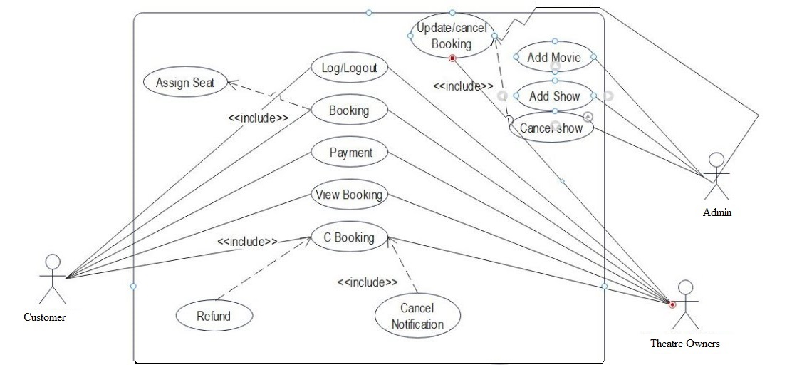

**4.6 User Stories for Customer Registration**

**Customer Registration:**

As a < unauthorized user >

I want to < sign up for the MovieTicketBooking application through a sign-up form >

So that < I can access to movies list. >

## **Acceptance Criteria:**

1. While signing up-Use Name, Username, Email, and Password and Confirm Password.
2. If sign up is successful, it will get automatically logged in.
3. If I sign up with an incorrect detail which are specified in step1, I will receive an error Message for incorrect information.
4. If we are trying to sign up with an existing email address, we will receive an error Message saying "email exists."

**4.6.2 User Stories for Customer Login**

**Customer Login:**

As a < authorized user >

I want to < log in for MovieTicketBooking application >

So that < I can have access to the application.>

## **Acceptance Criteria:**

1. While logging in, Username and password are required.

2. After successful log in, it will be redirected to the main page.

3. If we are trying to login with incorrect username or password, then error message will be displayed as "invalid login”.

**4.6.3 User Stories for Search Movie**

**Search Movie:**

As a < user >

I want to < search for a movie in MovieTicketBooking Application>

So that < I can book a Movieticket in a specific theater.>

**Acceptance Criteria:**

1. While searching, Valid theater should be specified.

2. And also, Available movie in the theater.

3. Checking for availability of a Movieticket on specific date always should be current date and ahead of the current date.

4. Searching based on the theater Location.

5. Price listing as per the theater.

**4.6.4 User Stories for View Movie Details**

**View Movie Details:**

As a < user >

I want to < view the movie details in a Particular movie >

So that < I can easily book the movie ticket in the application >

**Acceptance Criteria:**

1. While view the movie details, its show the current theater name, movie name and show timings.

2. And also, show remaining tickets available.

3. Checking about the movie description of the particular movie.

4. And also shows the movie ticket price.

5. Also view the new trending movie details.

6. View Trailers of currently running movies.

7. Shows the QR code or ticket number.

**4.6.5 User Stories for TheaterOwner Registration**

**TheaterOwner Registration:**

As a < unauthorized user >

I want to < sign up for the MovieTicketBooking application through a sign-up form >

So that < I can access to movies list. >

## **Acceptance Criteria:**

1. While signing up-Use Name, Username, Email, and Password and Confirm Password.

2. If sign up is successful, it will get automatically logged in.

3. If I sign up with an incorrect detail which are specified in step1, I will receive an error

Message for incorrect information.

4. If we are trying to sign up with an existing email address, we will receive an error Message saying "email exists."

**4.6.6 User Stories for Theater Owner Login**

**Theater Owner Login:**

As a < authorized user >

I want to < log in for Movie Ticket Booking application >

So that < I can have access to the application. >

## **Acceptance Criteria:**

1. While logging in, Username and password are required.

2. After successful log in, it will be redirected to the main page.

3. If we are trying to login with incorrect username or password, then error message will be displayed as "invalid login”.

**4.6.7 User Stories for Add Movie and Show Timings**

**Add Movie:**

As a < admin >

I want to < add movies to the MovieTicketBooking application >

So that < the customer’s can easily book the movie tickets >

**Acceptance Criteria:**

1. While adding the movie to the application, to add the movie name, theater name, add timings.

2. And also add the movie timings and price.

3. Adding the Sessions of the all movies.

4. particular movie payment system are also added.

5. Add the theater location.

**Show Timings:**

As a < admin >

I want to < show timings of the particular movie and sessions >

So that < the customer can book movie tickets based on the their available timings >

**Acceptance Criteria:**

1. While view the movie details then show the particular movie timings.

2. Timings based on the morning ,afternoon and

night sessions.

3. Showing the Upcoming movies timings list.

**4.6.8 User Stories for Edit Movie.**

**Edit Movie:**

As a < admin >

I want to < Edit the movies >

So that < the customer’s can easily view and book the current and available movies only >

**Acceptance Criteria:**

1. In the edit page should be display the edit option of the all field.

2. While Edit the movie name, movie session, movie theater .

3. And also edit the theater location, movie timings.

4. delete the unavailable movie in the application.

5. Edit the only available theater in the current location.

6. Only shows the available timings in the current theater.

**4.6.9 User Stories for Booking Movie.**

**Booking Movie**

As a < user >

I want to < be able to make a booking for a specific movie >

So that < I can book Online >

**Acceptance Criteria:**

1. In the booking page should be display the booking details for the particular movie

2. In booking home page its display the fields for entering the customer name, movie name, theater name and also book button field for finally book the movie.

3. Booking the movie based on the trending list.

4. book the movie based on the near location theater available.

5. booking the movie in particular session.

6. The system should calculate the total price based on the selected dates and any additional charges.

7. The user should be prompted to provide their personal information, such as name, contact details, and any special requests.

8. After submitting the booking request, the user should receive a confirmation message or email with the booking details.

**4.6.10 User Stories for Cancel Booking**

**Cancel Booking:**

As a <user>

I want to <be able to cancel a booked movie ticket>

So that < I can Cancel Booking>

**Acceptance criteria:**

1. The system should provide a dedicated section or functionality for users to view and manage their bookings.

2. The user should be able to select the booking they wish to cancel.

3. Upon confirming the cancellation, the system should update the booking status as canceled.

4. If the cancellation is within the allowable cancellation period, the user should be eligible for a refund according to the ticket booking cancellation policy.

5. The user should receive a cancellation confirmation message or email with details of the cancellation and any applicable refund.

**4.6.11 User Stories for Logout**

As a < authorized user >

I want to < log out of application >

so that < I can prevent unauthorized access of my profile. >

**Acceptance Criteria:**

When I log out of my account, I will be redirected to the log-in page**.**

|  |  |  |  |  |  |  |  |  |  |  |  |  |  |  |  |  |  |  |  |  |  |  |  |  |  |  |  |  |  |  |  |  |  |  |  |  |  |
| --- | --- | --- | --- | --- | --- | --- | --- | --- | --- | --- | --- | --- | --- | --- | --- | --- | --- | --- | --- | --- | --- | --- | --- | --- | --- | --- | --- | --- | --- | --- | --- | --- | --- | --- | --- | --- | --- |
| **Student Name:** Divyaprada G   |  |  |  |  | | --- | --- | --- | --- | | Communication Address | Email ID | divyaprada6@gmail.com |  | | H M S  Polytechnic,  Shetti Halli  Main Road ,  Tumkur - 572103 | Contact Number | 8197075014 | | Date OF Birth | 22/11/2004 |      |  | | --- | | **Objective** | | To work in a dynamic and result-oriented atmosphere, which provides me with a challenging career and opportunity for growth so that my skills and knowledge can be utilized to the best. |      |  |  |  |  |  | | --- | --- | --- | --- | --- | | **Academic Qualification** | |  |  |  | | **Course** | **Institution** | **University/ Board** | **Year of Passing** | **Percentage of Marks** | | **Diploma in**  **Computer Science and**  **Engineering** | **H M S**  **Polytechnic** | **Board Of**  **Technical**  **Education** | **2024** | **93.53%** | | **10th standard** | **Chaithanya Vidya Mandira** | **Karnataka School**  **Examination and**  **Assessment Board** | **2021** | **80%** |      |  | | --- | | **Certificate Courses** | | 1. **The complete Full Stack Development – Skill up** 2. **Certified Full stack Development in Java – Pralotech Solutions** |      |  | | --- | | **Computer Proficiency** | | **Python, HTML, CSS, JAVA, MySQL.** |      |  | | --- | | **Project Work** | | **Name: Movie Ticket Booking.**  **Position: Developer**  **Software: Netbeans, Jdk 1.8, SQL Yog, MySql.** | |
| |  | | --- | | **Description:**  **The Movie Ticket Booking System project aims to develop a system or application that facilitates the efficient management and booking of Movie Ticket accommodations.** | |  |      |  | | --- | | **Personal Details** | | * **Father’s Name: Gangadhar C V.** * **Martial Status: Unmarried.** * **Area of Interest: Full Stack Development.** * **Linguistic Ability: English, Kannada.** * **Nationality: Indian.** |      |  | | --- | | **Declaration** |   I Divyaprada G Certify that to the Best of my knowledge and Belief, these data Correctly Describe my Qualification, My experience, and me.      **Signature** |

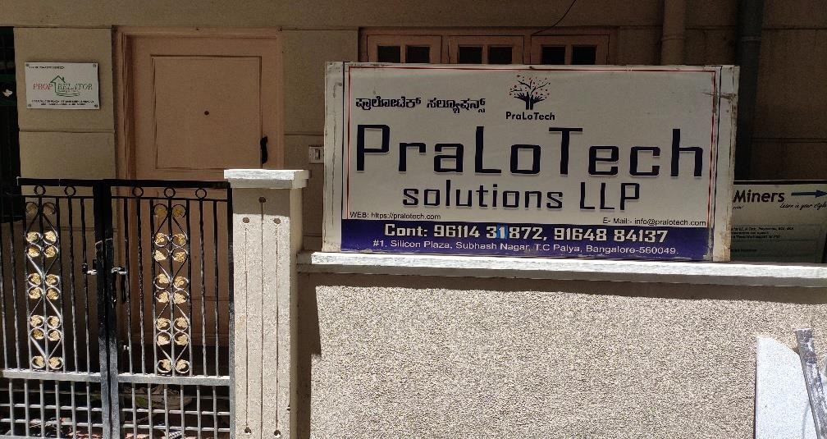

**Outside the Office**

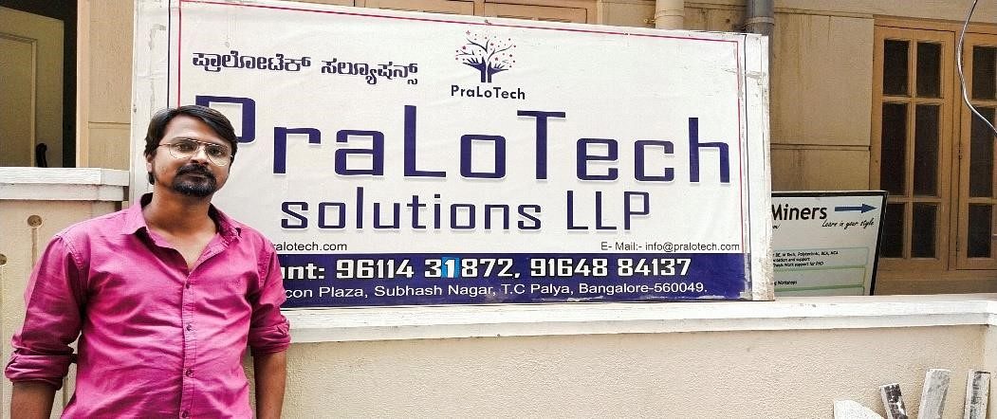

**LOHIT C (Director and Project Manager)**

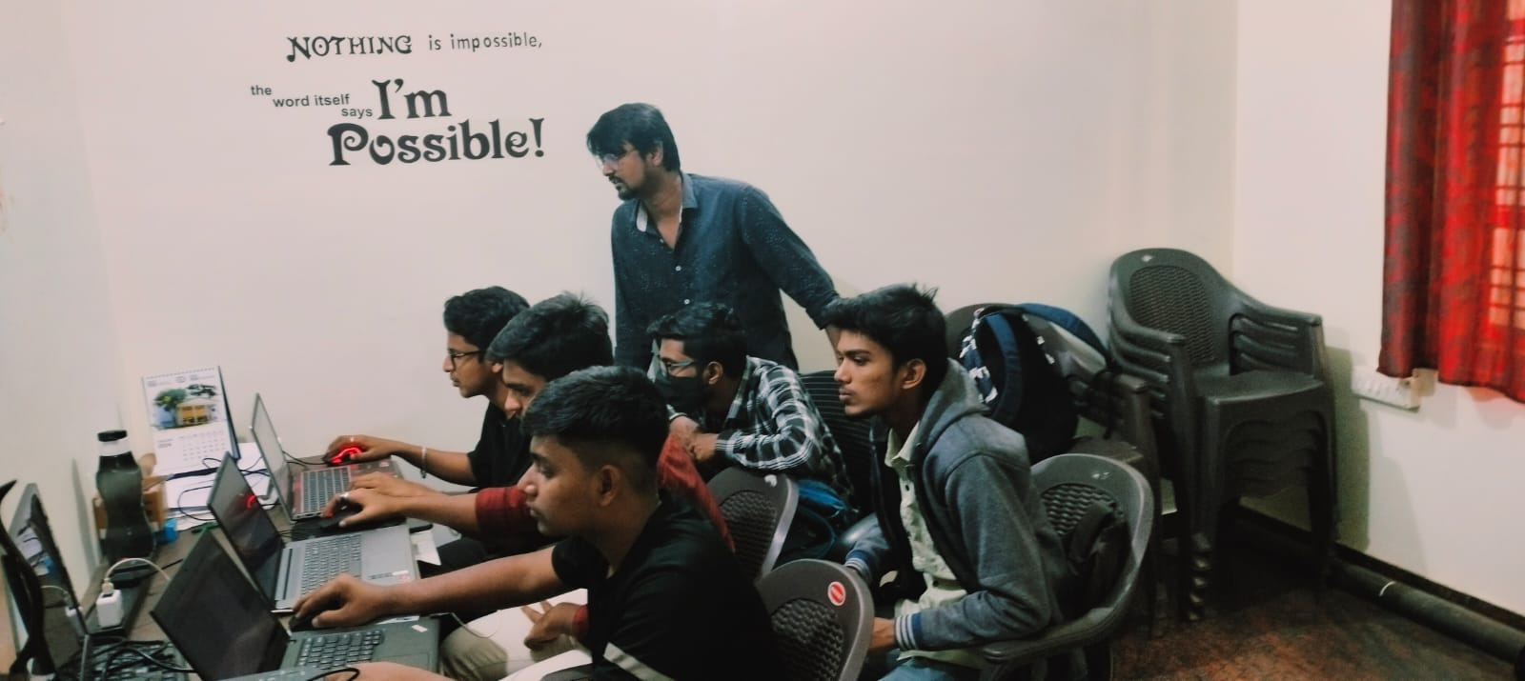

**Coding Class For Boys**

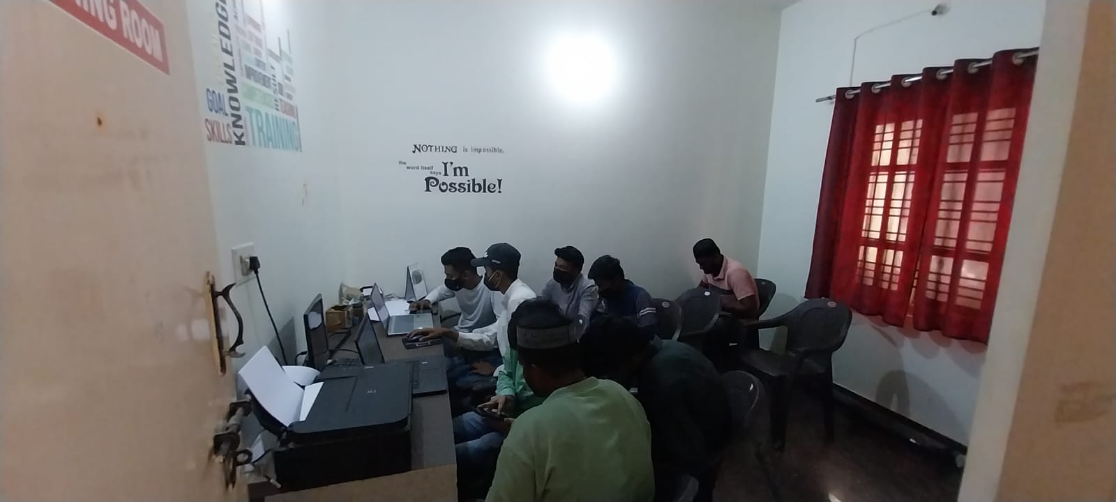

**Embedded System Class For Boys**

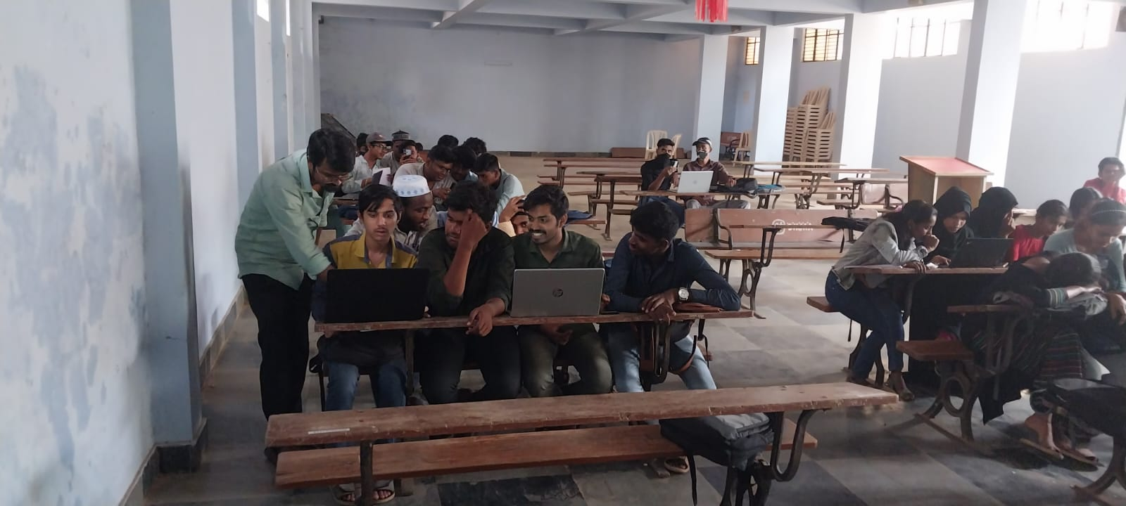

**Student Clearing His Doubts.**

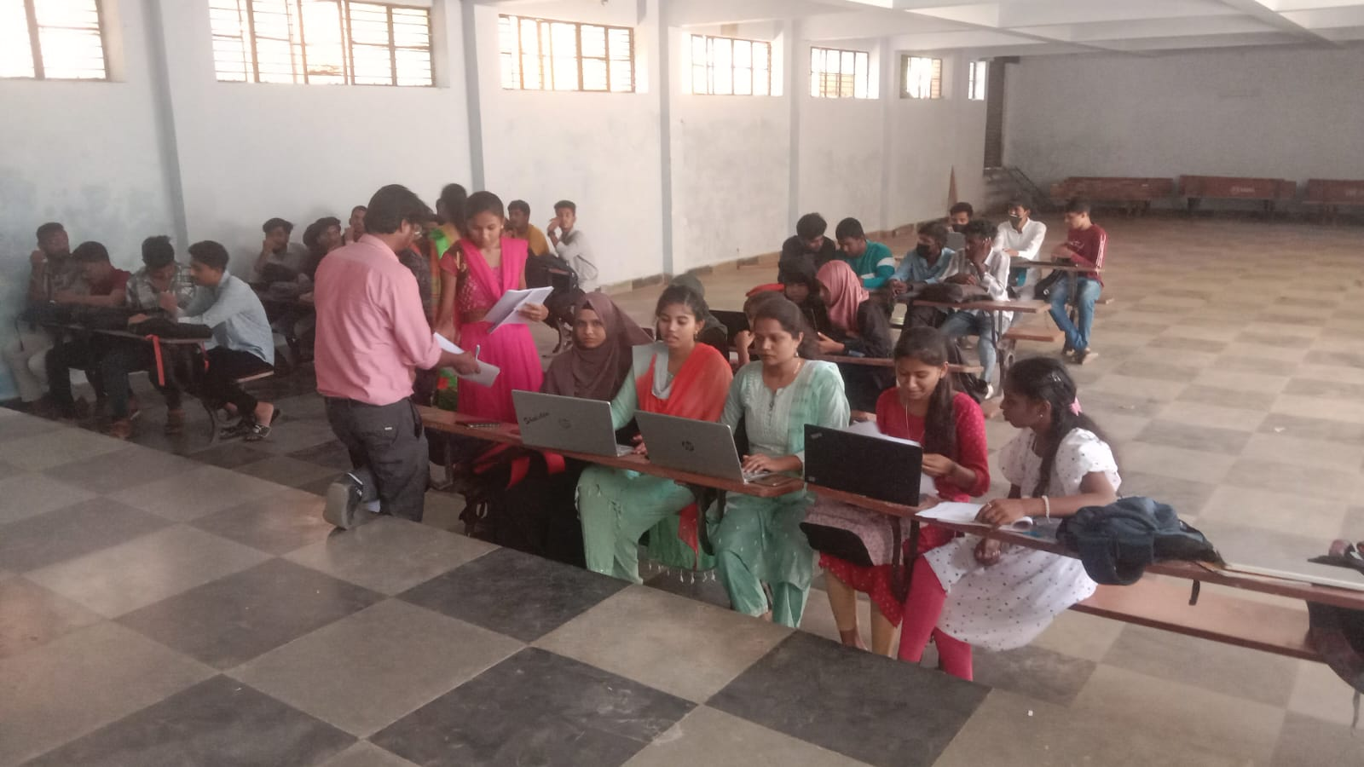

**Embedded System Class For Girls**

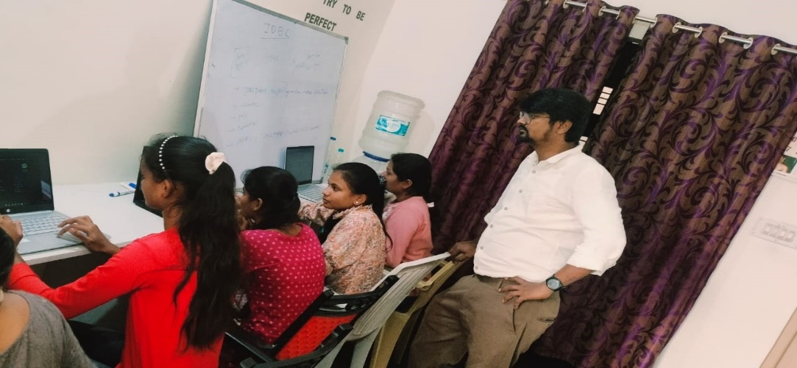

**Code Class for Girls**

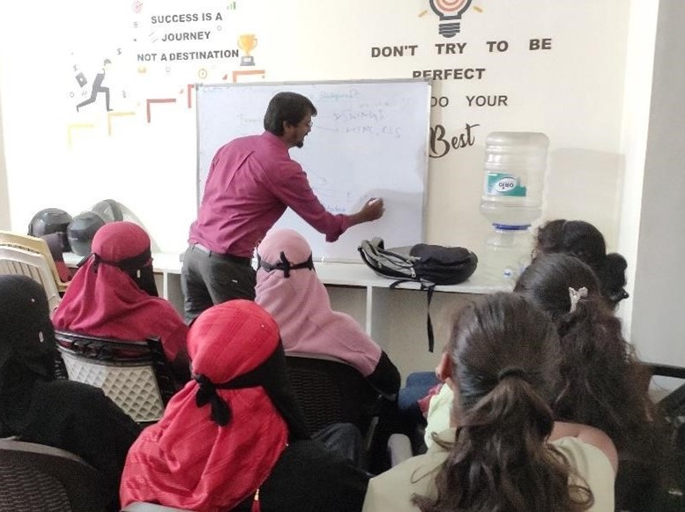

**Explaining Front End Development for Girls**



**Group Photo**



**Group photo of boys 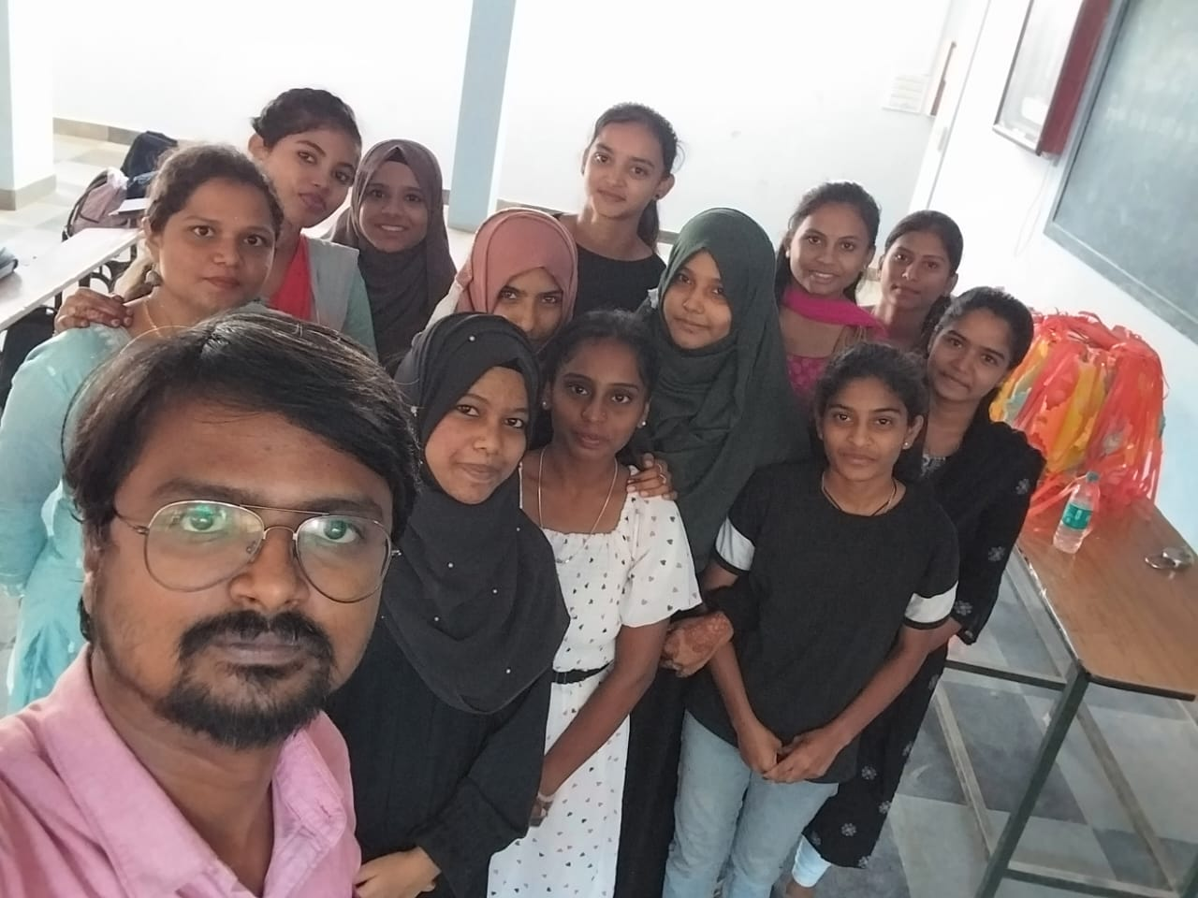 Group Photo of Girls**

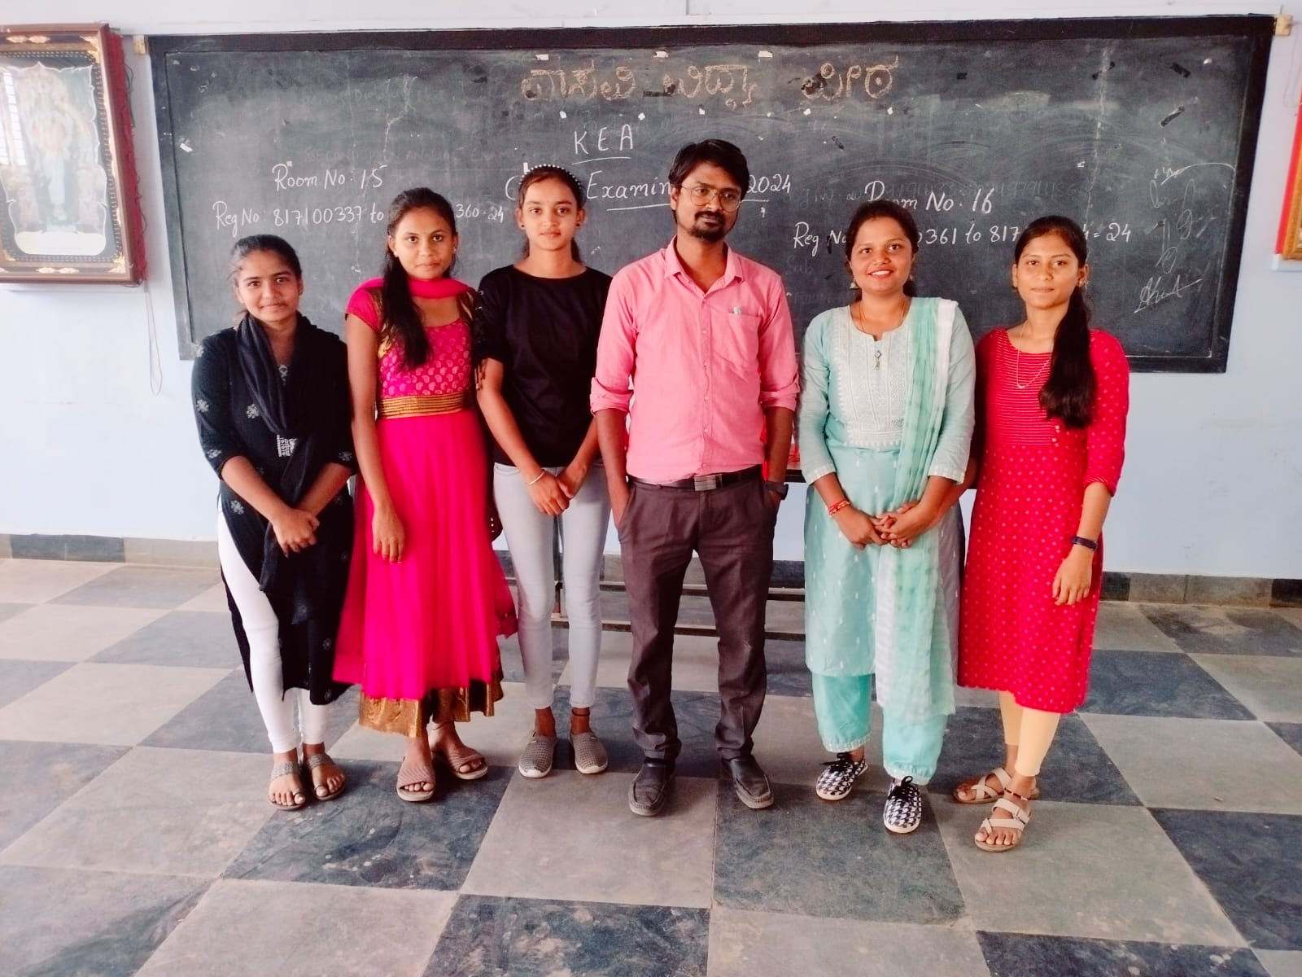

**Photo According to Batch Wise**

#### Some Random Photos

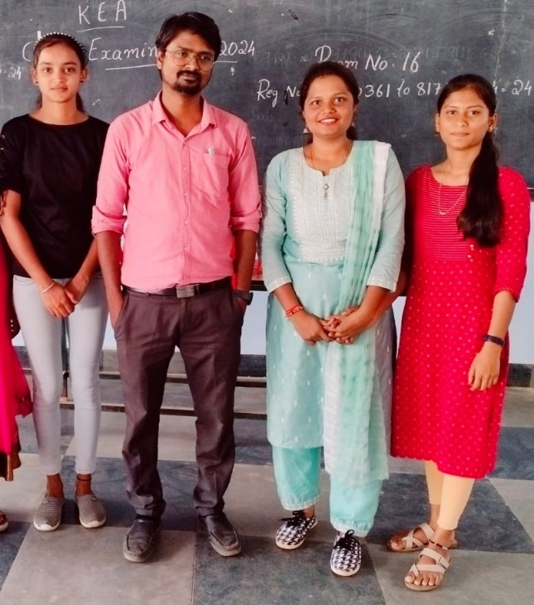

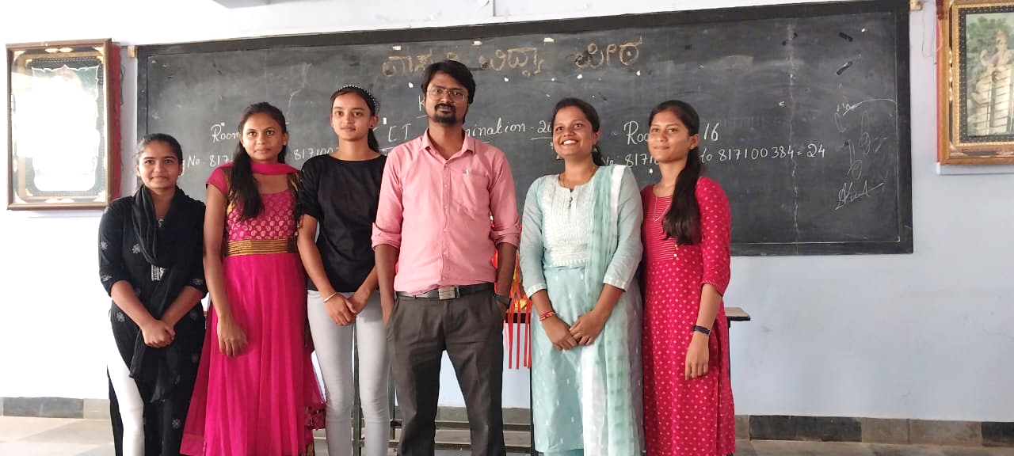

#### Appendices

**Software Requirement Specification**

Software requirement Specification is a fundamental document, which forms the foundation of the software development process. It not only lists the requirements of a system but also has a description of its major feature. An SRS is basically an organization's understanding (in writing) of a customer or potential client's system requirements and dependencies at a particular point in time (usually) prior to any actual design or development work. It's a two-way insurance policy that assures that both the client and the organization understand the other's requirements from that perspective at a given point in time. The SRS also functions as a blueprint for completing a project with as little cost growth as possible. The SRS is often referred to as the "parent" document because all subsequent project management documents, such as design specifications, statements of work, software architecture specifications, testing and validation plans, and documentation plans, are related to it. It is important to note that an SRS contains functional and nonfunctional requirements only; it doesn't offer design suggestions, possible solutions to technology or business issues, or any other information other than what the development team understands the customer's system requirements to be.

**5.1 Functional Requirement**

Functional Requirement defines a function of a software system and how the system must behave when presented with specific inputs or conditions. These may include calculations, data manipulation and processing and other specific functionality. In this system following are the functional requirements:-

1. Register the Information of Customers and Login.
2. Book the Slots.
3. Store into DB

**5.2 Non-functional Requirement**

Non functional requirements are the requirements which are not directly concerned with the specific function delivered by the system. They specify the criteria that can be used to judge the operation of a system rather than specific behaviors. They may relate to emergent system properties such as reliability, response time and store occupancy. Non functional requirements arise through the user needs, because of budget constraints, organizational policies, the need for interoperability with other software and hardware systems or because of external factors such as:-

1. Product Requirements
2. Organizational Requirements
3. User Requirements
4. Basic Operational Requirements

**5.2.1 Product Requirements**

**Portability:** Since the software is developed in java it can be executed on any platform for which the JVM is available with minor or no modifications.

**Correctness:** It followed a well-defined set of procedures and rules to compute and also rigorous testing is performed to confirm the correctness of the data.

**Ease of Use:** The front end is designed in such a way that it provides an interface which allows the user to interact in an easy manner.

**Modularity:** The complete product is broken up into many modules and well-defined interfaces are developed to explore the benefit of flexibility of the product.

**Robustness:** This software is being developed in such a way that the over all performance is optimized and the user can expect the results within a limited time with utmost relevancy and correctness. Java itself possesses the feature of robustness, which implies the failure of the system is negligible.

Non functional requirements are also called the qualities of a system. These qualities can be divided into execution quality & evolution quality. Execution qualities are security & usability of the system which are observed during run time, whereas evolution quality involves testability, maintainability, extensibility or scalability.

**5.2.2 Organizational Requirements**

**Process Standards:** IEEE standards are used to develop the application which is the standard used by the most of the standard software developers all over the world.

**Design Methods:** Design is one of the important stages in the software engineering process. This stage is the first step in moving from problem to the solution domain. In other words, starting with what is needed design takes us to work how to satisfy the needs.

The design of the system is perhaps the most critical factor affecting the quality of the software and has a major impact on the later phases, particularly testing and maintenance. We have to design the product with the standards which has been understood by the developers of the team.

**5.2.3 User Requirements**

* The user must be able to visualize Graphical User Interface Window.
* The user must be able to configure all the parameters with neat GUI.

**5.2.4 Basic Operational Requirements**

The customers are those that perform the eight primary functions of systems engineering, with special emphasis on the operator as the key customer. Operational requirements will define the basic need and, at a minimum, will be related to these following points:-

**Mission profile or scenario:** It describes about the procedures used to accomplish mission objective. It also finds out the effectiveness or efficiency of the system.

**Performance and related parameters:** It points out the critical system parameters to accomplish the mission

**Utilization environments:** It gives a brief outline of system usage. Finds out appropriate environments for effective system operation.

**Operational life cycle:** It defines the system lifetime.

**5.3 Resource Requirement**

**NetBeans IDE 7.4:** Netbean is a multi-language [software development environment](http://en.wikipedia.org/wiki/Software_development_environment) comprising an [integrated development environment (IDE)](http://en.wikipedia.org/wiki/Integrated_development_environment) and an extensible [plug-in](http://en.wikipedia.org/wiki/Plug-in_%28computing%29) system. It is written primarily in [Java](http://en.wikipedia.org/wiki/Java_%28programming_language%29) and can be used to develop applications in Java and, by means of the various plug-ins, in other [languages](http://en.wikipedia.org/wiki/Programming_language) as well, including [C,](http://en.wikipedia.org/wiki/C_%28programming_language%29) [C++,](http://en.wikipedia.org/wiki/C%2B%2B) [COBOL,](http://en.wikipedia.org/wiki/COBOL) [Python,](http://en.wikipedia.org/wiki/Python_%28programming_language%29) [Perl,](http://en.wikipedia.org/wiki/Perl) [PHP,](http://en.wikipedia.org/wiki/PHP) and others. Netbean employs plug-ins in order to provide all of its functionality on top of (and including) the runtime system, in contrast to some other applications where functionality is typically [hard coded.](http://en.wikipedia.org/wiki/Hard_code) The Netbean SDK includes the Netbean java development tools (JDT), offering an IDE with a built-in [incremental](http://en.wikipedia.org/wiki/Incremental_compiler) Java compiler and a full model of the Java source files. This allows for advanced [refactoring](http://en.wikipedia.org/wiki/Refactor) techniques and code analysis. The IDE also makes use of a workspace, in this case a set of [metadata](http://en.wikipedia.org/wiki/Metadata) over a flat file space allowing external file modifications as long as the corresponding workspace "resource" is refreshed afterwards.

**Swing:** The Java Foundation Classes (JFC) consists of five major parts: AWT, Swing, and

Accessibility, Java 2D, and Drag and Drop. Java 2D has become an integral part of AWT, Swing is built on top of AWT, and Accessibility support is built into Swing. The five parts of JFC are certainly not mutually exclusive, and Swing is expected to merge more deeply with AWT in future versions of Java. Swing is a set of classes that provides more powerful and flexible components than are possible with the AWT. In addition to the familiar components, Swing supplies tabbed panes, scroll panes, trees, and tables. It provides a single API capable of supporting multiple look-and feels so that developers and end-users are not locked into a single platform’s look-and-feel. The Swing library makes heavy use of the MVC software design pattern, which conceptually decouples the data being viewed from the user interface controls through which it is viewed. Swing possesses several traits such as—1. Platform-independence 2.Extensibility 3.Component-oriented 4.Customizable 5. Configurable 6. Look and feel. Platform independence both in terms of its expression and its implementation, extensibility which allows for the "plugging" of various custom implementations of specified framework interfaces Users can provide their own custom implementation of these components to override the default implementations. Component-orientation allows responding to a well-known set of commands specific to the component. Specifically, Swing components are [Java Beans](http://en.wikipedia.org/wiki/Java_Beans) components, compliant with the Java Beans Component Architecture specifications. Through customizable feature users will programmatically customize a standard Swing component by assigning specific borders, colors, backgrounds, opacities, etc, configurable that allows Swing to respond at runtime to fundamental changes in its settings. Finally look and feel allows one to specialize the [look and feel](http://en.wikipedia.org/wiki/Look_and_feel#Look_and_Feel_in_Widget_Toolkits) of [widgets,](http://en.wikipedia.org/wiki/Widget_%28computing%29) by modifying the default via runtime parameters deriving from an existing one, by creating one from scratch, or, beginning with J2SE 5.0, by using the  [Look and Feel](http://en.wikipedia.org/wiki/Synth_Look_and_Feel) which is configured with an [XML](http://en.wikipedia.org/wiki/XML) property file.

**5.4 System Requirements**

**Hardware Requirements**

|  |  |  |  |  |
| --- | --- | --- | --- | --- |
| Processors |  | **:** |  | Intel I3 2.2 Ghz |
| RAM |  | **:** |  | 4 GB. |
| Storage |  | **:** |  | 100 GB. |

Monitor **:**  15”

Keyboard **:**  Standard 102 keys

**Software (Tools &Technologies) Requirements**

|  |  |
| --- | --- |
| Coding | : Java |
| Platform | : JDK |
| Tool | : Netbeans |
| OS | : Windows 7 |
| Cloud | : Cloud AWS |
| Database | : MySQL |